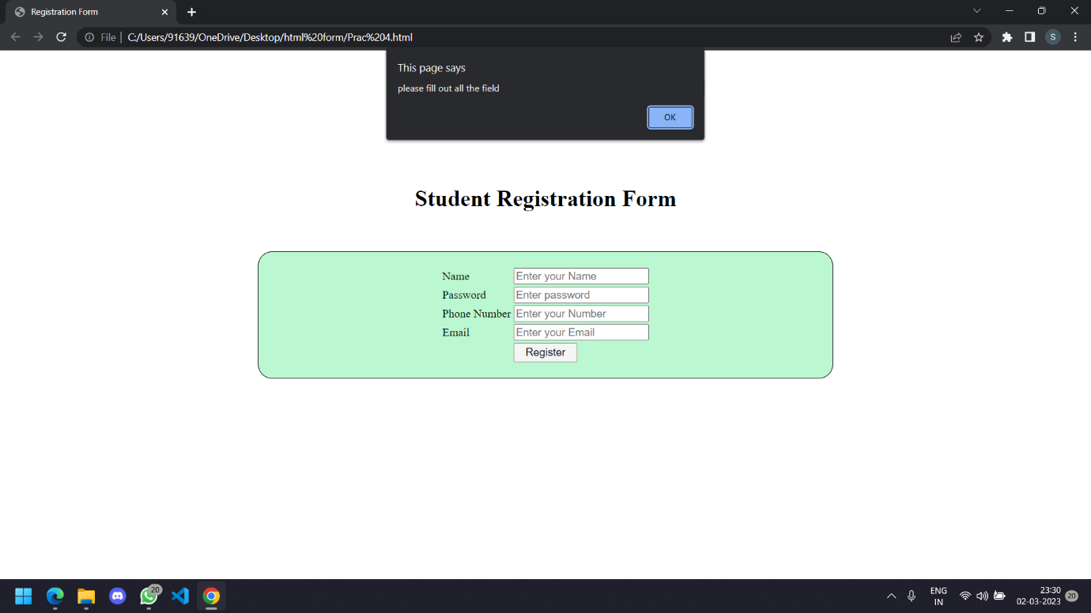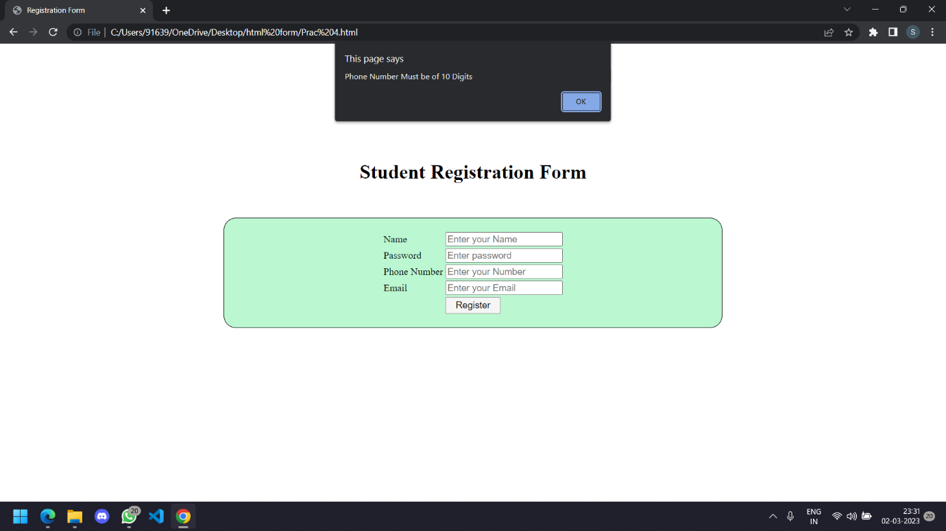

Sinhgad Academy Of Engineering

Name :- Kaushikram Chakka, Roll No.:- COTA28

Class:- T.E, Div:- A, Sub:- Web Technology

